**LAخSLY**



**Graduation Project Overview and Block Diagrams**

**Team Members:**

Ahmed Maher

Ahmed Salama

Moamen Hassan

Mohamed Talaat

**Supervised by:**

Dr.Magda Fayek

**Introduction**

We have two reasons which motivated us to develop an automated system for soccer match summarization.

**First**, for individuals; most people cannot watch all matches which are played at the same time within different time zones because of lack of time.

**Second**, for professionals; coaches need to view the highlighted events to truly developing plans and to evaluate their team players. From this point we concluded the importance of our proposed program to put a solution for the mentioned problem.

**Problem Definition**

Summarization process is an essential part in several applications such as (Information retrieval, video retrieval, speech retrieval … etc), we need to retrieve only an important data from a whole one. This field is undergoing rapid change, as computers are now prevalent in virtually every application, from games for children through the most sophisticated planning tools for governments and multinational firms.

Suppose that we have a soccer match and we need to summarize it by using a computer-based application, our concern here is to extract the most exciting events in the soccer game such as goal and goal attempts using our proposed application afterwards output those events into summarized video.

**Scope of Work**

There are many kinds of sports such as basketball, tennis, baseball, hockey, and soccer. We choose to work on soccer game, because it is a popular sport around the world. It has many challenges such as different transitions, hard cuts, and long duration.

We will work on European champions league as a starting point of datasets and we can increase the number of these championships in the future, because there are different approaches to differentiate events from one championship to another and the various approaches considered in our proposed system dedicated for these championships.

Project overview

In order to truly detect the high-level events in sport video, we need to extract some low-level features such as (color, texture, shape and motion). In addition, cinematic feature such as (shot-types, shot-length and replays) introduce another factor that we need when we are working on sport video to produce summarized events.

When we are talking about a soccer game, we can refer to it as a continuous sport which means that if there is an existence of such a break during the match, it can an indicator of the occurrence of important event such as (goal, penalty shot and red/yellow card). Therefore, the summarization process which we aimed for can be recognized by a combination of these events, for example the summarized segment may contains only the goal shots, goal attempts or penalty shots that can be described as important events.

In this approach, we are going to highlight the most important events such as (Goals, Goal attempts), facilitate the process of automatic match, save the viewer’s time.

This is dedicated to professionals to enable sport satellite channels automatically highlight the important events in a match. These help professionals to comment on them and help trainers to analyze their team performance, and to interested users to provide the most important events of an entire match under constraint of limited viewing.

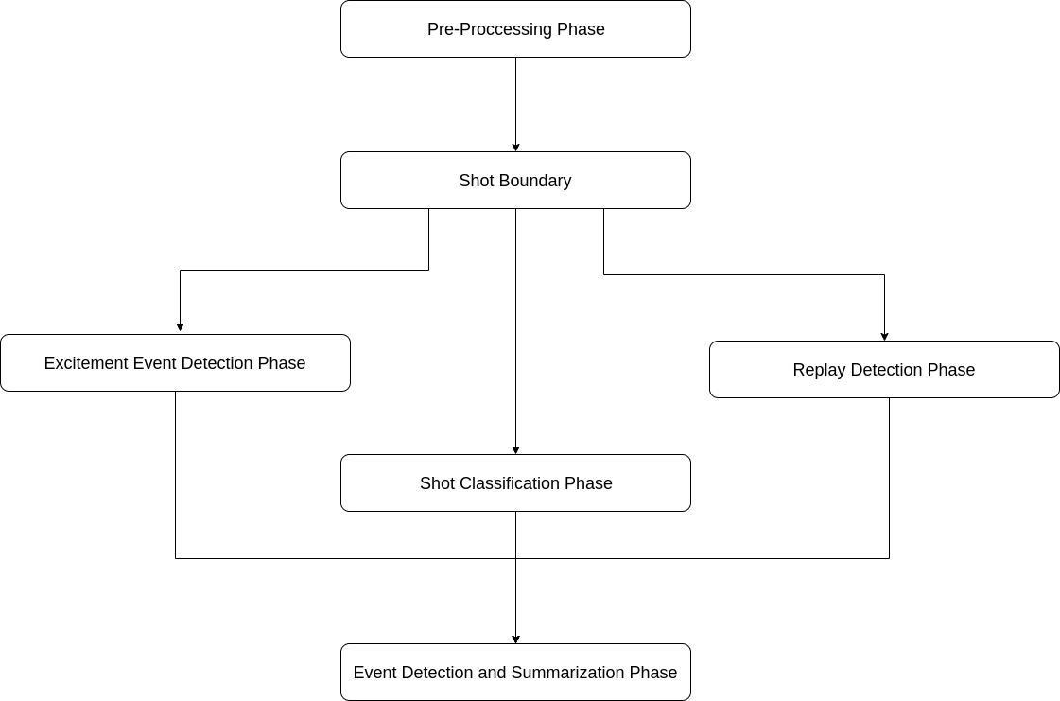

Proposed system Block Diagram

Now we’ll take a look at each phase and it’s techniques

1. **Pre-processing Phase**

The goal of this phase is to read the video file and apply any color space transformations or any video processing necessary for the following phases.

1. **Shot Boundary Phase**

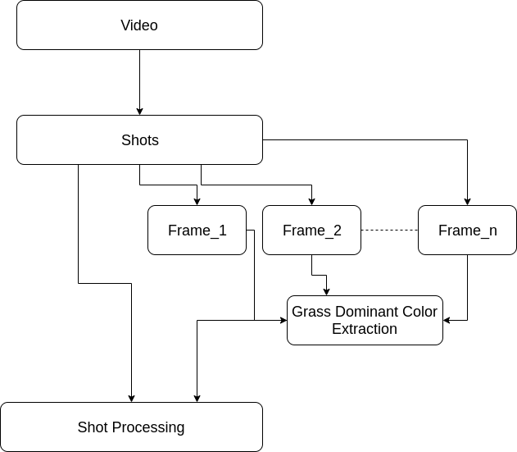

Football matches are broadcasted using multiple cameras positioned at various locations in the stadium on the pitch on off the pitch.

A shot can be defined as a sequence of frames recorded during a continuous motion of the camera so the match will be a sequence of shots from those cameras so we intend to separate these shots.

But unfortunately, the shot by itself gives us little new information so video analysis on a shot basis could not fully use all the essential information in a soccer video.

So, we solve this in the shot classification phase.

1. **Shot Classification Phase**

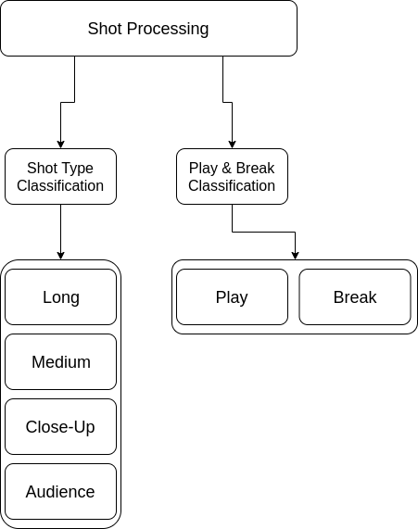

We will try to classify each shot as a long, Medium, close-up or an Audience Shot

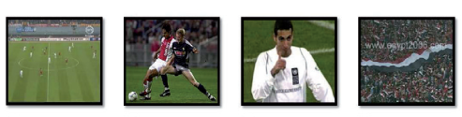

Also classify each shot as a play or break shot.

We are hoping to achieve this by extracting the grass dominant color of the frame.

1. **Excitement Event Detection Phase**

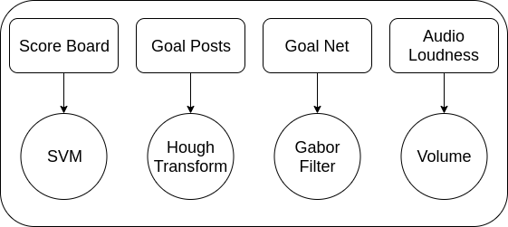

In this phase we will try to detect the scoreboard in the top left corner of the frame by using svm classifier or image processing techniques such as border detection an extract the score for scoreboard and detect goals if the score changes

Also detecting the goal posts and net and testing the audio loudness will help us if there is goal.

1. **Replay Detection phase**

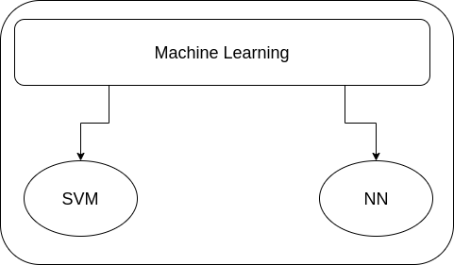

Before a replay occurs a logo appears on the screen as a transiton between the live feed and the replay.

In this phase we want to detect that logo to detect the replays because of course replays are an important highlight of the match

1. **Event Detection And Summarization Phase**

In this phase we will use the output of the previous phases and examine the order of the consecutive shots and using that order we’ll conclude if it is a highlight or not.

Example: when a goal is scored 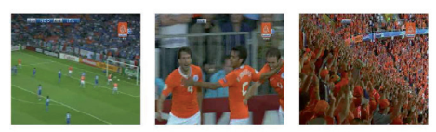

Long view Close up Audience

After finishing all the phases, the highlight video will be available on the website (Laخsly) for the user to view it.

**User interactions with the website**

